6)Form Validations

1)App-component.html

<body>

<h1> Angular 6 Reactive Form Validation</h1>

<form  (ngSubmit)="submitForm()">

  <div>

  <label for="firstname">firstname:</label>

  <input type="text" id="firstname" name="firstname" formControlName="firstname"

 required>

  <div \*ngIf="signupForm?.get('firstname')?.errors?.['required']">Username is

 required.</div>

  <div \*ngIf="signupForm?.get('firstname')?.errors?.['minlength']">Username must be at

 least 5 characters long.</div>

  </div>

  <div>

    <label for="lastname">lastname:</label>

    <input type="text" id="lastname" name="lastname" formControlName="lastname"

   required>

    <div \*ngIf="signupForm?.get('lastname')?.errors?.['required']">Username is

   required.</div>

    <div \*ngIf="signupForm?.get('lastname')?.errors?.['minlength']">Username must be at

   least 3 characters long.</div>

    </div>

  <div>

  <label for="email">Email:</label>

  <input type="email" id="email" name="email" formControlName="email" required>

  <div \*ngIf="signupForm?.get('email')?.errors?.['required']">Email is required.</div>

  <div \*ngIf="signupForm?.get('email')?.errors?.['email']">Invalid email format.</div>

  </div>

  <div>

  <label for="password">Password:</label>

  <input type="password" id="password" name="password" formControlName="password"

 required>

  <div \*ngIf="signupForm?.get('password')?.errors?.['required']">Password is

 required.</div>

  <div \*ngIf="signupForm?.get('password')?.errors?.['minlength']">Password must be at

 least 8 characters long.</div>

  </div>

  <button type="submit">Register</button>

 </form></body>

2)app-component.ts

import { Component, OnInit } from '@angular/core';

import { FormBuilder, FormGroup, Validators } from '@angular/forms';

@Component({

  selector: 'app-root',

 templateUrl: './app.component.html',

 styleUrls: ['./app.component.css']

})

export class AppComponent {

 title(title: any) {

 throw new Error('Method not implemented.');

 }

 signupForm: FormGroup;

 constructor(private formBuilder: FormBuilder) {

 this.signupForm = this.formBuilder.group({

 username: ['', [Validators.required, Validators.minLength(5)]],

 email: ['', [Validators.required, Validators.email]],

 password: ['', [Validators.required, Validators.minLength(8)]]

 });

 }

 submitForm() {

 if (this.signupForm.valid) {

 console.log(this.signupForm.value); // Log the form values to the console

 }

 }

}

3)app-module.ts

import { NgModule } from '@angular/core';

import { BrowserModule } from '@angular/platform-browser';

import { AppRoutingModule } from './app-routing.module';

import { AppComponent } from './app.component';

import { ReactiveFormsModule} from '@angular/forms'

@NgModule({

  declarations: [

    AppComponent

  ],

  imports: [

    BrowserModule,

    AppRoutingModule

  ],

  providers: [],

  bootstrap: [AppComponent]

})

export class AppModule { }

Output:

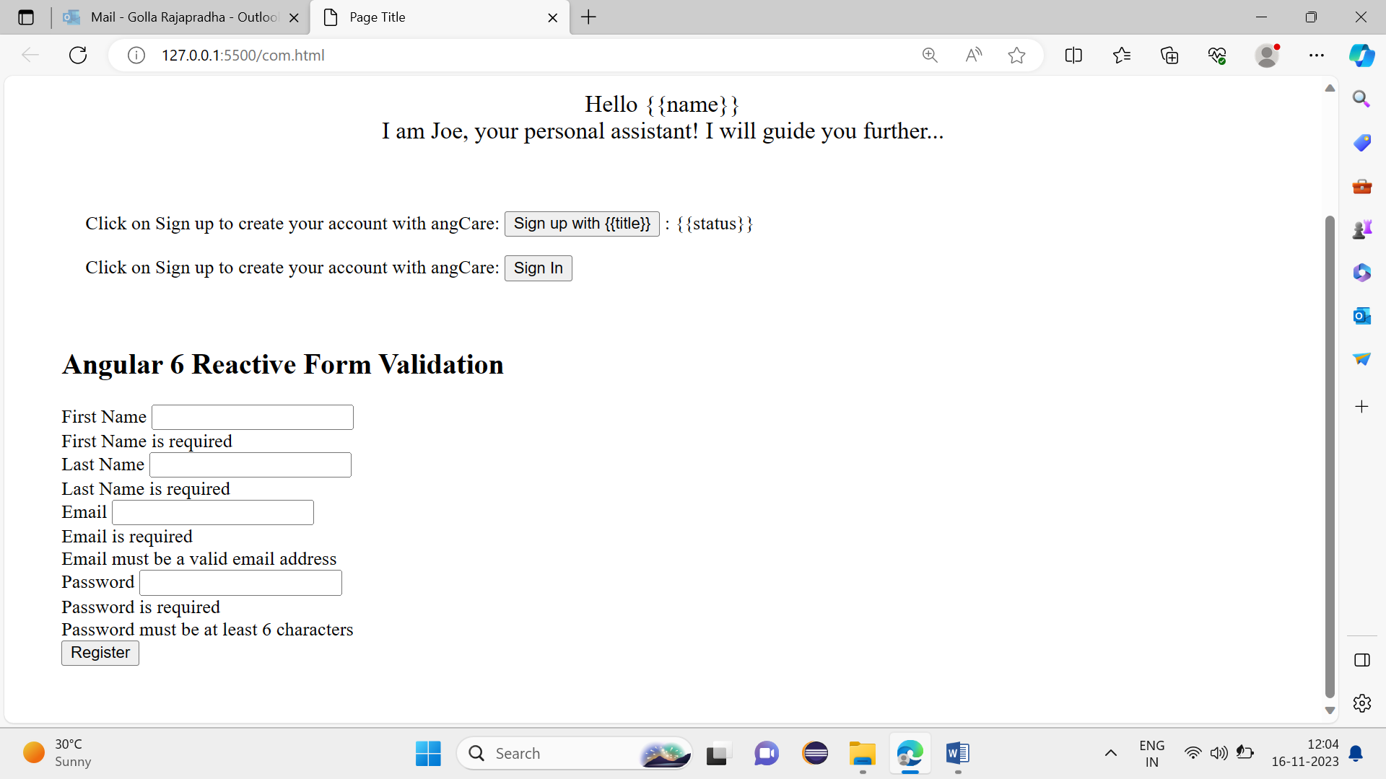

Bottom of Form